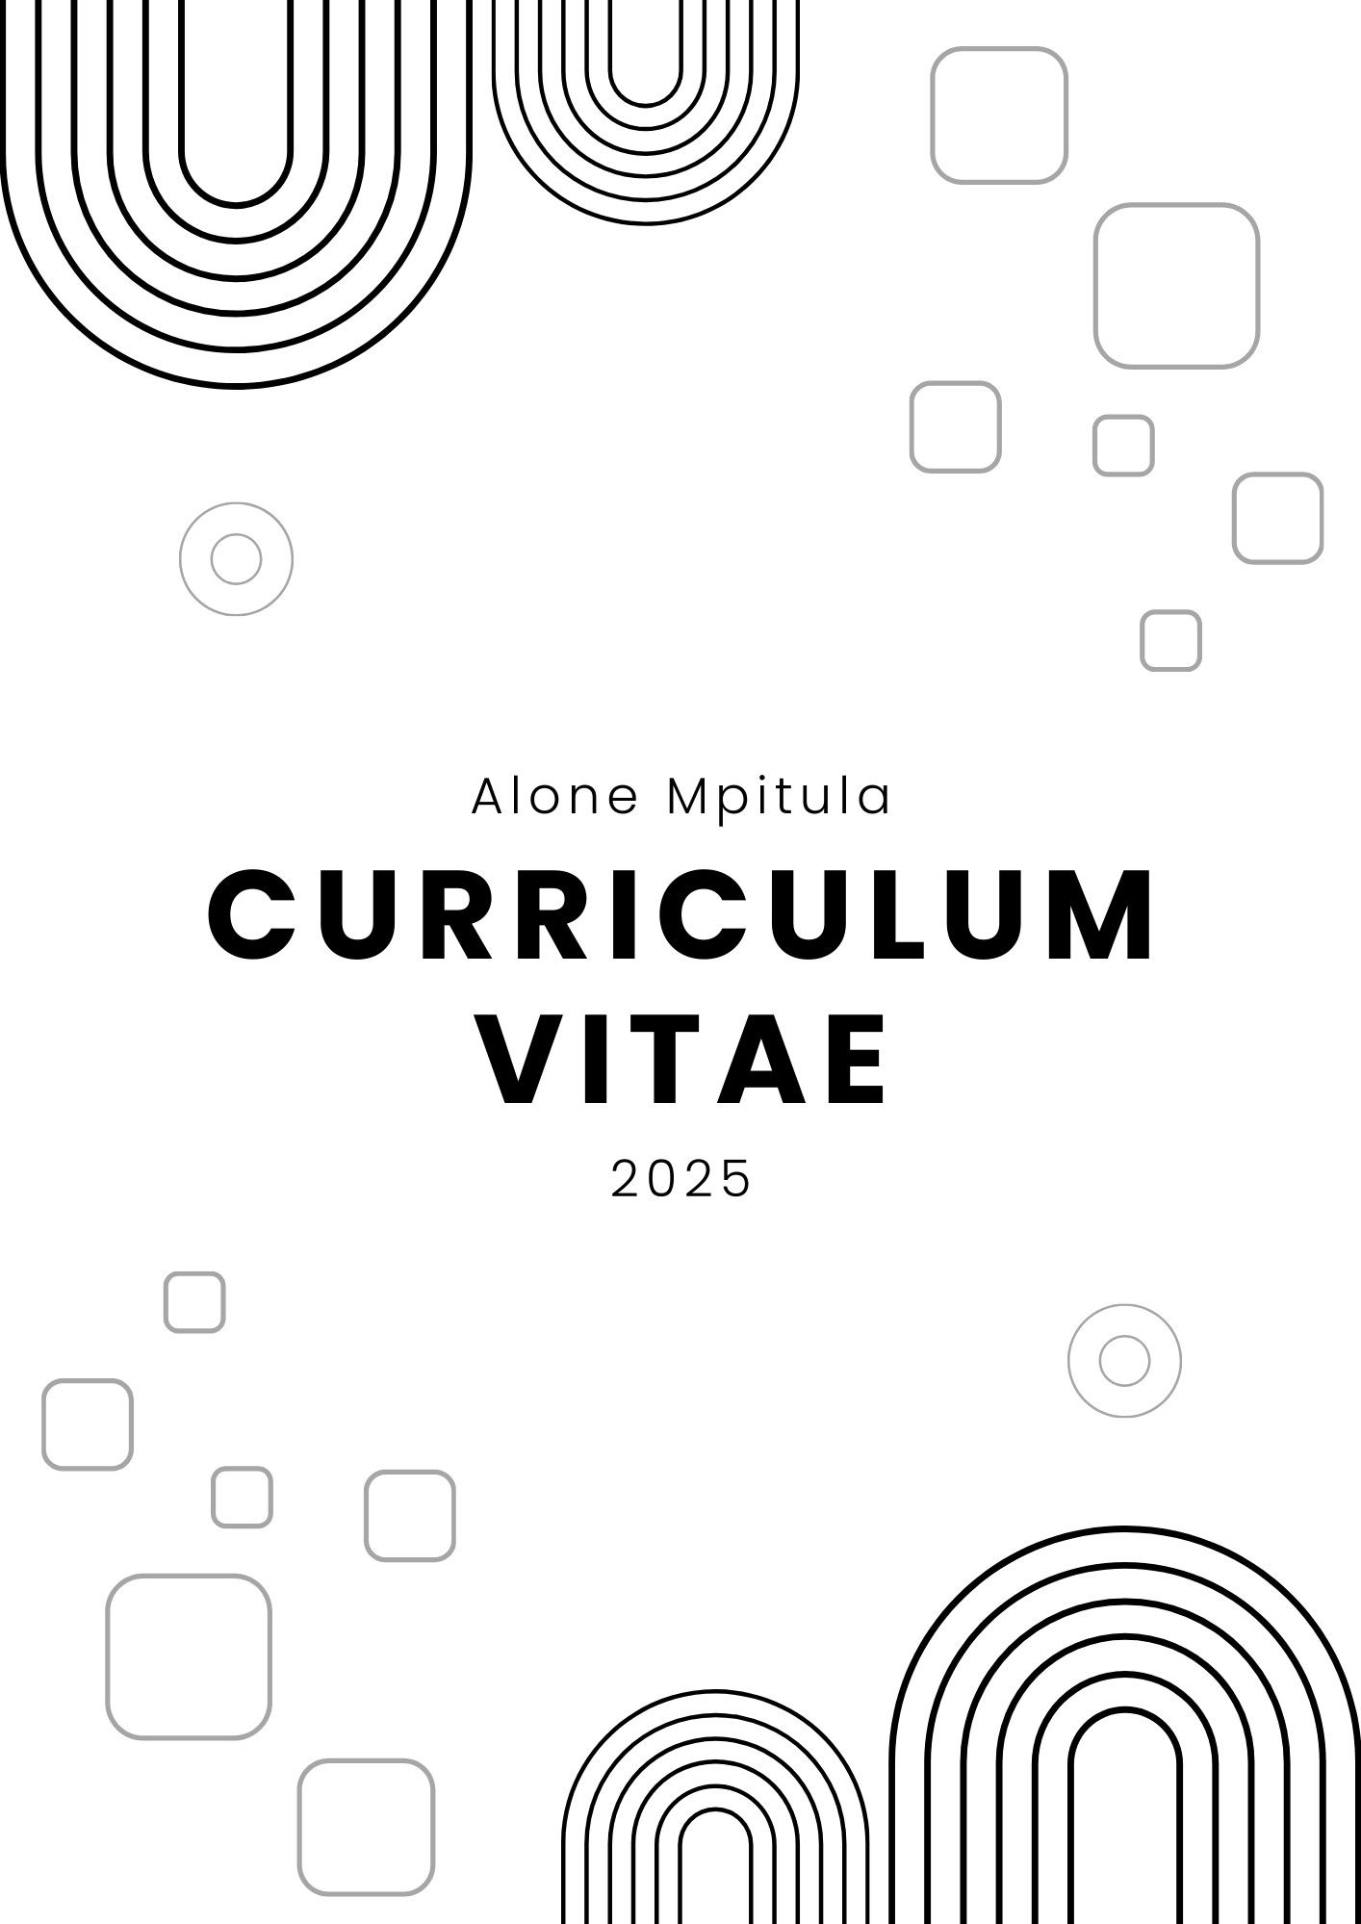

**Alone Mpitula**

067 690 0131 | [Alonemapitlula@gmail.com](mailto:Alonemapitlula@gmail.com)| 28617 Coral Bells Street | Vereeniging NU, 1456 | Gauteng

# Personal Details

* Date of Birth: 13-01-2002
* Nationality: South African
* Gender: Male
* [LinkedIn](https://www.linkedin.com/in/alone-mpitula/)
* [GitHub](https://github.com/Mpitula)

# Professional Summary

I am an aspiring Information Technology graduate with a solid foundation in computing, I am enthusiastic about leveraging technology to create innovative solutions that address real-world challenges. My academic journey was enhanced by tutoring, Data capturing and projects that are focus on **C#**, **.NET**, **ASP.NET Core**, and **SQL**. With strong analytical skills, and a commitment to continuous learning, I am enthusiastic about full-stack development and delivering high-quality solutions across both front-end and back-end systems.

# Experience

## Tutor – Mathematics, Physical sciences & Life Science

Ithuteng Extra Lessons, Lawley

*August 2020 – January 2021*

* I was providing academic support and guidance to assist secondary school learners to improve and excel in their studies and achieve their educational goals.

## Student Assistant - STTN 121 (Intro Stat Inference I)

North-West University, Vanderbijlpark

*July 2022 – November 2022*

* Script marking.

## Tutor - MTHS 113 (Basic Mathematical Techniques)

North-West University, Vanderbijlpark

*February 2023 – June 2024*

* Provided academic support to first-year IT students with first semester module.

## Data Capture

North-West University, Vanderbijlpark

*July 2024 – November 2024*

* Capturing and optimizing attendance class lists by tutors, cleaning and displaying the data professionally using Microsoft Excel for statistical purposes.
* Collaborated with team members to optimize data collection and management workflow ensuring prominent levels of accuracy and compliance.

# Education

## Grade 12 – Matric

*Lawley Thuto-Lefa Secondary School, Lawley*

## Virtual assistant skills in the digital age

*Alx Africa*

## Bachelor of Science in Information Technology

Major: Computing

*North-West University, Vanderbijlpark*

# Certificates

* **UiPath:** Introduction to Automation.
* **Alison Empower:** Agile Master Training.

## Microsoft Learn:

* + Build a web API with minimal API, ASP.NET and NET.
  + Source control for machine learning projects.
  + Secure your Azure resources with Azure role-based access control (Azure RBAC).

# Technical Skills

* **Technology Integration:** Skilled in deploying APIs and software solutions on platforms like Azure.
* **Languages:** C#, Python, C++, HTML & CSS, JavaScript, Java, SQL
* **Frameworks:** .NET, ASP.NET Core, Node.js
* **Databases:** MySQL
* **Developer Tools:** Visual Studio Code, Visual Studio
* **Automation, Cloud & Deployment:** UiPath, Microsoft Azure
* **Version Control:** GitHub

# Projects

## Portfolio

This project is a personal portfolio website designed to highlight my skills, projects, and professional experience. I built it using HTML, CSS, and JavaScript and provides responsive and interactive user experience.

## NWU Tech Trends

Development of a CRUD RESTful API connected to a database and deploying it on azure. Application management Telemetries (add, delete, and update Telemetries)

## NWU Tech Trends (Telemetry Portal - MVC)

Web application design to manage CRUD functionality for projects and client’s data. The application is

built using asp.net core MVC and follows the best practices in software design patterns. Application is hosted on azure and connected on the azure SQL database.

## NWU Tech Trends (Telemetry Portal - User Acceptance Test)

UiPath project that automates the crude operations on a web application for managing clients and projects using data from an Excel file and updates the Excel file with the results of each operation showing whether it passed or failed.

## NWU Tech Trends Benefit Realization

## This project involves creating a Power BI report to showcase the benefits realized by NWU Tech Trends through the implementation of reporting on time saved by each project and client.

# Extracurricular Activities

## USSA Chess Tournament (2023 & 2024)

Represented NUW, Honing strategical thinking and analytical skills.

# References

## Mr. J. Matlhong

*Sports Manager, NWU Chess*

**Phone:** 074 817 7425

**Email:** [Joseph.Matlhong@nwu.ac.za](mailto:Joseph.Matlhong@nwu.ac.za)

## Mr. VM. Marumo

*Director, Ithuteng Extra Lessons*

***Phone:*** *073 907 8643*

## Ms. Dine Du Preez

*Coordinator, Student academic development and support*

**Phone:** 073 568 8942

**Email:** [Dine.DuPreez@nwu.ac.za](mailto:Dine.DuPreez@nwu.ac.za)

